- Log-in as Administrator on XVI
XVI Administrator login

Map to drive:

- Launch the Service Export Utility software from XVI desktop

- Select XVIClinical on the Database dropdown menu.

- Select “Export the calibration files” from the tickbox.

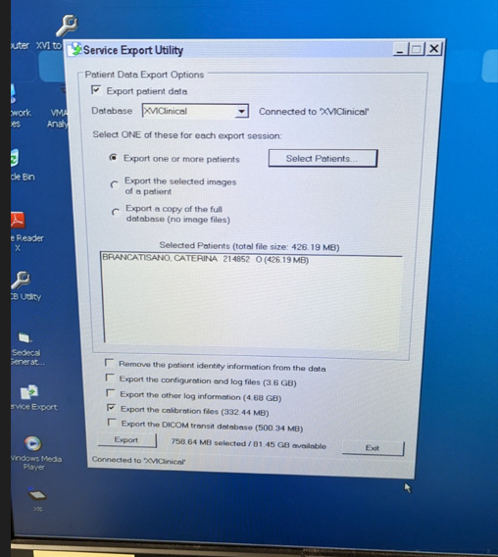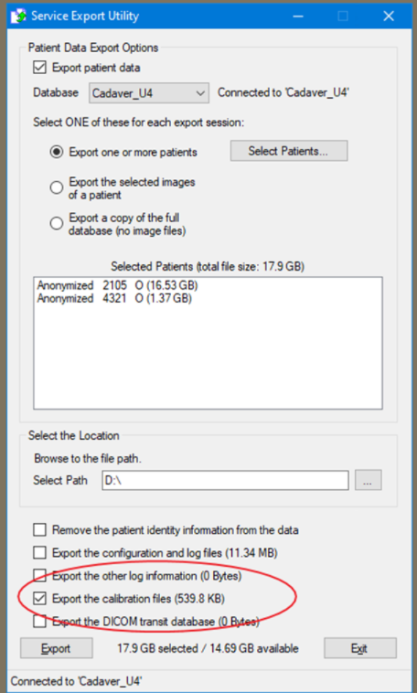

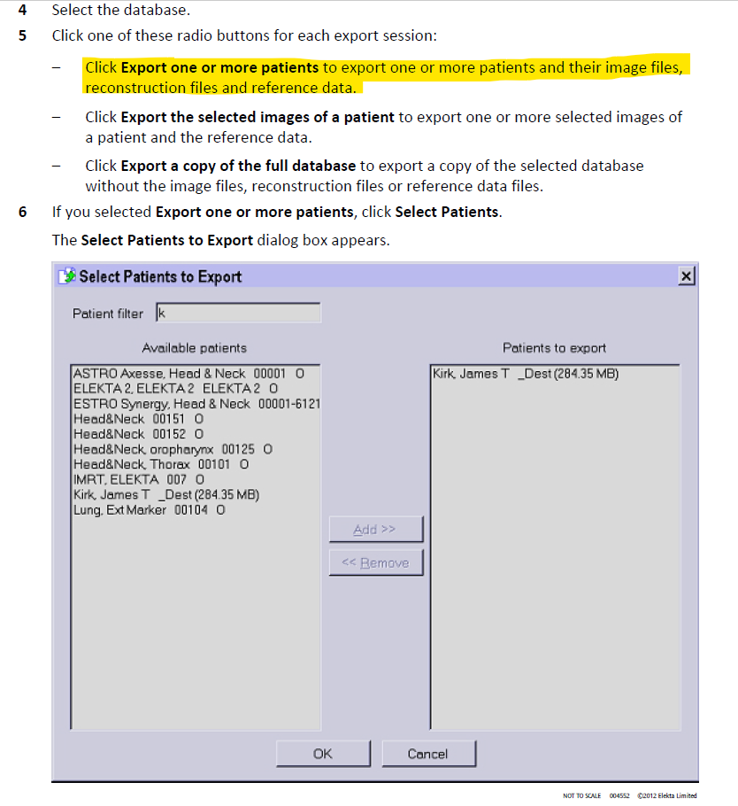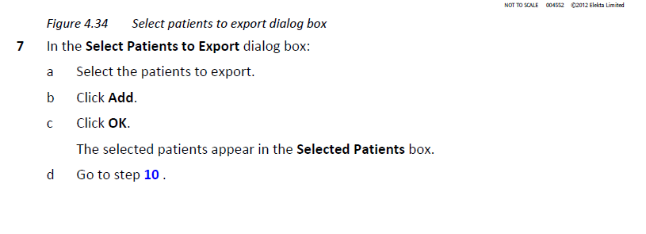
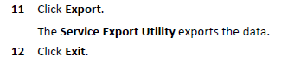

Additional notes for MUH/CRO:

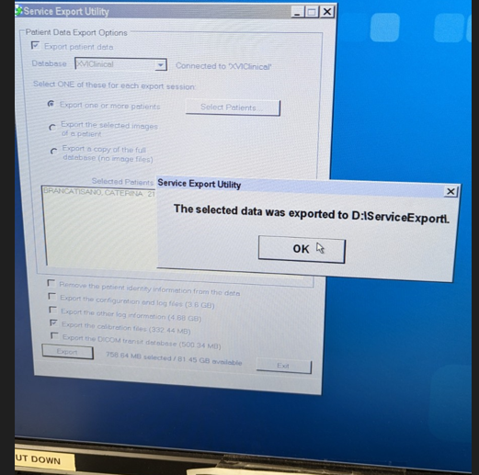
- The exported patient folder will be saved to D:/ServiceExport.

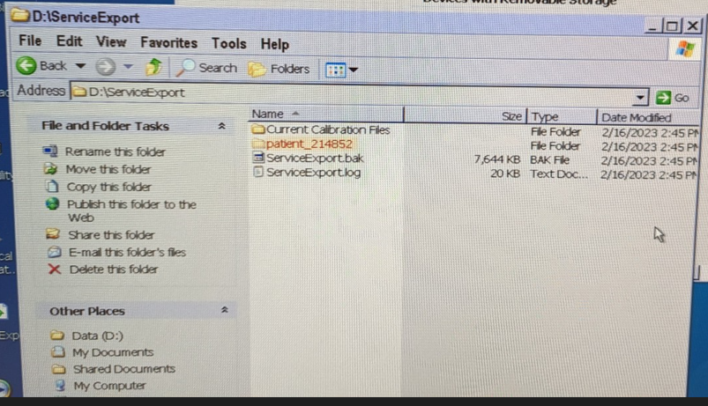

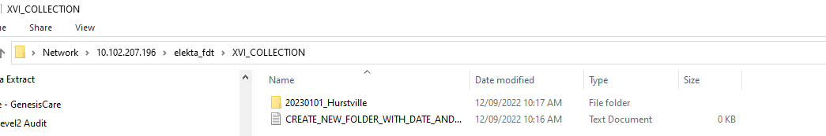
- Open this location \\10.102.207.196\elekta_fdt\XVI_COLLECTION

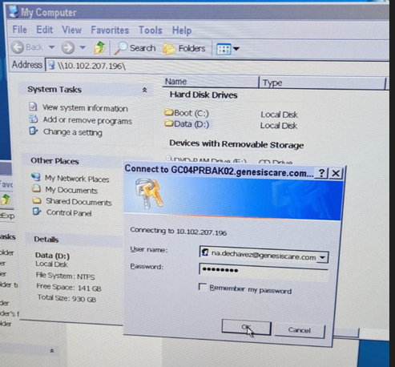
- You will be asked to log-in using - to access this location.

- Create a folder named with date of export and machine name e.g. 20230214_Jupiter_MUH

- Cut and paste patient folders from D:/ServiceExport in this created folder within \\10.102.207.196\elekta_fdt\XVI_COLLECTION
